**Binary Tree Data Structure**

A tree whose elements have at most 2 children is called a binary tree. Since each element in a binary tree can have only 2 children, we typically name them the left and right children.

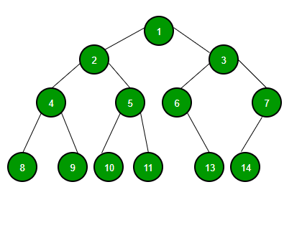

**Binary Search Tree Data Structure**

A binary Search Tree is a node-based binary tree data structure that has the following properties:

* The left subtree of a node contains only nodes with keys lesser than the node’s key.
* The right subtree of a node contains only nodes with keys greater than the node’s key.
* The left and right subtree each must also be a binary search tree.
* There must be no duplicate nodes.

Lightbox

**Difference between Binary Tree and Binary Search Tree:**

| S. No. | Basis of Comparison | BINARY TREE | BINARY SEARCH TREE |
| --- | --- | --- | --- |
| 1. | Definition | BINARY TREE is a nonlinear data structure where each node can have at most two child nodes. | BINARY S EARCH TREE is a node based binary tree that further has right and left subtree that too are binary search tree. |
| 2. | Types | * Full binary tree * Complete binary tree * Extended Binary tree and more | * AVL tree * Splay Tree * T-trees and more |
| 3. | Operations | BINARY TREE is unordered hence slower in process of insertion, deletion, and searching. | Insertion, deletion, searching of an element is faster in BINARY SEARCH TREE than BINARY TREE due to the ordered characteristics |
| 4. | Structure | In BINARY TREE there is no ordering in terms of how the nodes are arranged | In BINARY SEARCH TREE the left subtree has elements less than the nodes element and the right subtree has elements greater than the nodes element. |
| 5. | Data Representation | Data Representation is carried out in a hierarchical format. | Data Representation is carried out in the ordered format. |
| 6. | Duplicate Values | Binary trees allow duplicate values. | Binary Search Tree does not allow duplicate values. |
| 7. | Speed | The speed of deletion, insertion, and searching operations in Binary Tree is slower as compared to Binary Search Tree because it is unordered. | Because the Binary Search Tree has ordered properties, it conducts element deletion, insertion, and searching faster. |
| 8. | Complexity | Time complexity is usually O(n). | Time complexity is usually O(logn). |
| 9. | Application | It is used for retrieval of fast and quick information and data lookup. | It works well at element deletion, insertion, and searching. |
| 10. | Usage | It serves as the foundation for implementing Full Binary Tree, BSTs, Perfect Binary Tree, and others. | It is utilized in the implementation of Balanced Binary Search Trees such as AVL Trees, Red Black Trees, and so on. |